MIT HEALTH CENTER WEBPAGE

STOCKS PAGE:

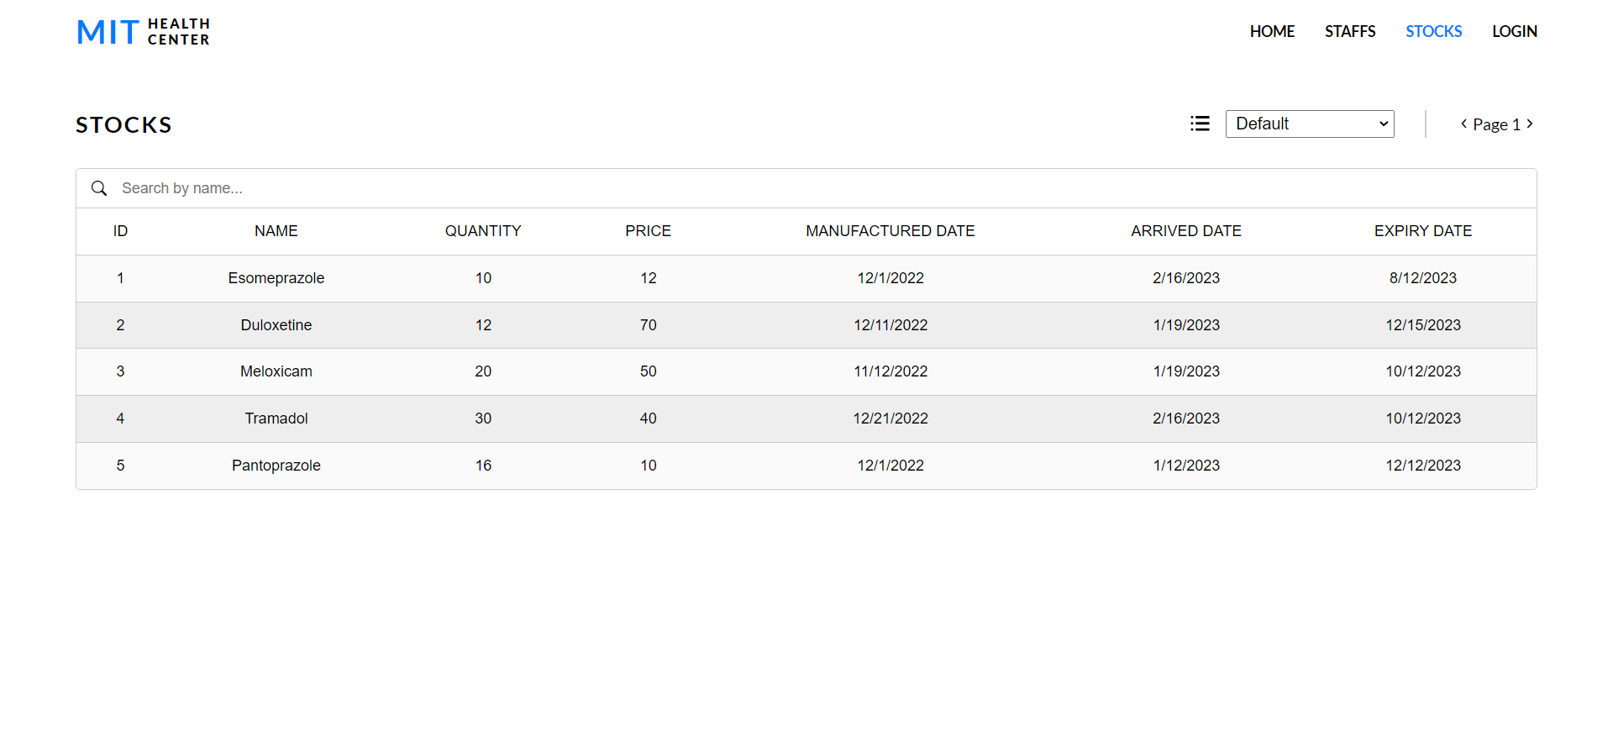

LOGIN PAGE:

STOCKS PAGE (AFTER LOGIN):

STOCKS SORTED BY NAME:

STOCKS IN DIFFERENT PAGE:

ADD PAGE: (CAN BE ACCESSED ONLY BY ADMIN)

STOCK ADDED:

LOGGING IN AS PHARMACIST:

STOCKS PAGE ONCE LOGGED IN AS PHARMACIST:

UPDATE PAGE:

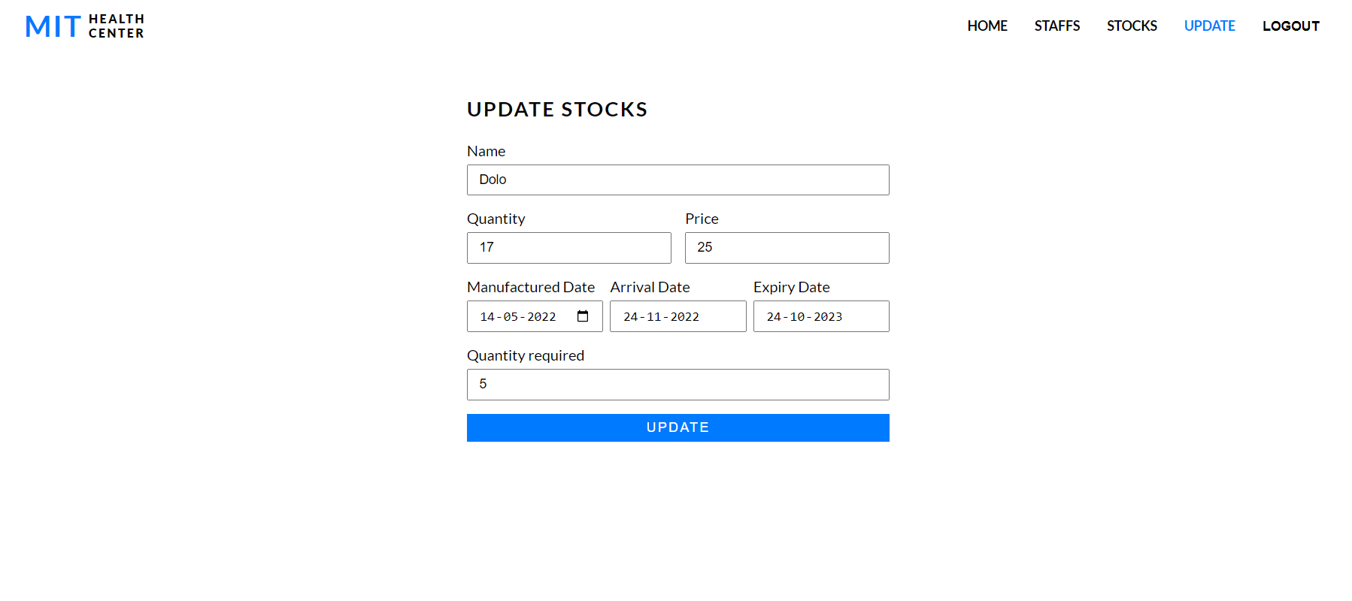

QUANTITY UPDATED IN STOCKS PAGE:

MOBILE VIEW OF THE WEBSITE:

